**I have read and understood the course academic integrity**

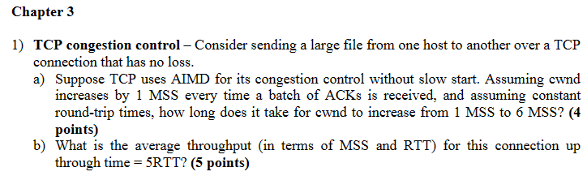

1. **Because in Additive Increase state, sending rate increase by one on every RTT.**

**So Ans_time = 6 -1 = 5 RTT**

1. **Avg.throughput = (1+2+3+4+5) mss / 5RTT = 3/4 * 6MSS / RTT = 3 MSS/RTT**

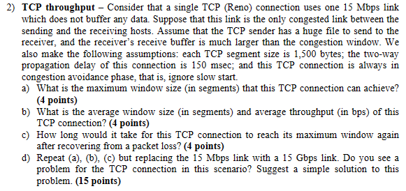

1. **Wmax = LinkSpeed * RTT / SegmentSize**

**= 15*10^6 b * 0.15/ （8*1500） bits**

**= 187.5 ≈ 187**

1. **Avg.W = 3/4 W = 3/4 * 187 = 140.25 seg**

**Avg.throughPut = 3/4 W*MSS/ RTT = 3/4 * 30*1500bytes/ 0.15*2 = 11220000 bps**

1. **In Reno the window size will increase by 1 per RTT after cutted in half.**

**Time = (W- W/2)*RTT = (187 – 187/2) * 0.15 = 14.025s**

1. **Wmax = LinkSpeed * RTT / SegmentSize = 187500 seg**

**Avg.W = 3/4 W = 3/4*187500 = 140625**

**Avg.throughput = 3/4 * 187500*1500*8/0.1 = 1.125*10^10bps**

**Time = w/2 * RTT = 14062.5s**

**The recover time will be 14062.5s, it is too long. Using TCP CUBIC would be a possible solution, it will increase the recover speed. Or implement ECN to window size also can reduce the recover time.**

